# Commercial Building Disclosure (CBD) Program Expansion Public Consultation Paper

#### What is the Commercial Building Disclosure Program?

The Commercial Building Disclosure (CBD) Program requires energy efficiency information to be provided, in most cases, when commercial office space of 1000 square metres or more is offered for sale or lease. The aim of the CBD Program is to improve the energy efficiency of Australia's large office buildings and to ensure prospective buyers and tenants are informed. The CBD Program is established by the [*Building Energy Efficiency Disclosure Act 2010*](https://www.legislation.gov.au/Details/C2021C00490)(the BEED Act) and is managed by the Australian Government Department of Climate Change, Energy, the Environment and Water (the department).

The CBD Program has driven considerable energy savings for large commercial office buildings by empowering building owners and operators to make informed decisions to enhance energy efficiency and reduce consumption.

Since 2010, there has been a 35% reduction in base building energy usage per square meter for disclosure affected office buildings. According to a review conducted by the Centre for International Economics (CIE) in 2019, the CBD Program has delivered $83 million in energy bill savings from 2010 to 2019. This equates to 3PJ of energy savings.

Two major reviews of the CBD Program in 2016 and 2019 found that the existing program was effective and recommended expanding it.

You can find more information about the CBD Program at: [www.cbd.gov.au](http://www.cbd.gov.au)

#### Why is the government considering changes to the CBD Program?

The Australian Government has committed to reach net zero emissions by 2050. All segments of the economy will need to reduce their emissions to meet this goal.

In Australia, non-residential buildings contribute around 10% of total emissions in the economy, most of this outside the office sub-sector, representing significant opportunity to decarbonise. Expanding the CBD Program would be an opportunity to drive significant emissions savings in the commercial buildings sector.

Expanding the CBD Program over time to encompass most major commercial building types would encourage sectors that had not previously been exposed to building energy efficiency to consider changes. This whole-of-economy approach is more aligned with the significant change required to meet Australia’s 2030 and 2050 decarbonisation targets. Establishing whole-of-economy disclosure and benchmarking frameworks could also support other decarbonisation accelerators such as the finance sector.

In addition to the significant emissions reduction benefits, energy bill savings associated with reduced energy consumption is key benefit of the CBD Program. There is potential to expand energy bill savings associated with the CBD Program to more building types and sizes and empower more building owners and operators to make informed decisions that enhance energy efficiency and reduce consumption.

#### How does the current CBD Program work?

The CBD Program requires most sellers and lessors of office space of 1000 square metres or more to obtain a Building Energy Efficiency Certificate (BEEC) before the building goes on the market for sale, lease or sublease.

BEECs are valid for up to 12 months and include:

* the building's National Australian Built Environment Rating System (NABERS) Energy for offices star rating, and
* a tenancy lighting assessment (TLA) of the relevant area of the building.

The [*Building Energy Efficiency Disclosure Act 2010*](https://www.legislation.gov.au/Details/C2021C00490) (BEED Act) requires that:

* BEECs must be provided to potential buyers or lessees when requested at the time of sale, lease or sublease and be available on a public register administered by the department. This is the **trigger for disclosure**.
* the building's NABERS Energy star rating must also be included in any advertising material for the sale, lease or sublease. This is the **location for disclosure**.

#### What changes are the government considering?

Both the CIE review of the CBD Program in 2019 and a subsequent recent feasibility study by KPMG have suggested a staged expansion of the CBD Program to other ownerships structures, building types and sectors. The reports also canvass what energy and emissions information should be disclosed. You can find both of these reports at [www.cbd.gov.au](http://www.cbd.gov.au).

The feasibility study includes a suggested road map for introducing mandatory disclosure to most major commercial building sectors by 2035 (see Figure 1).

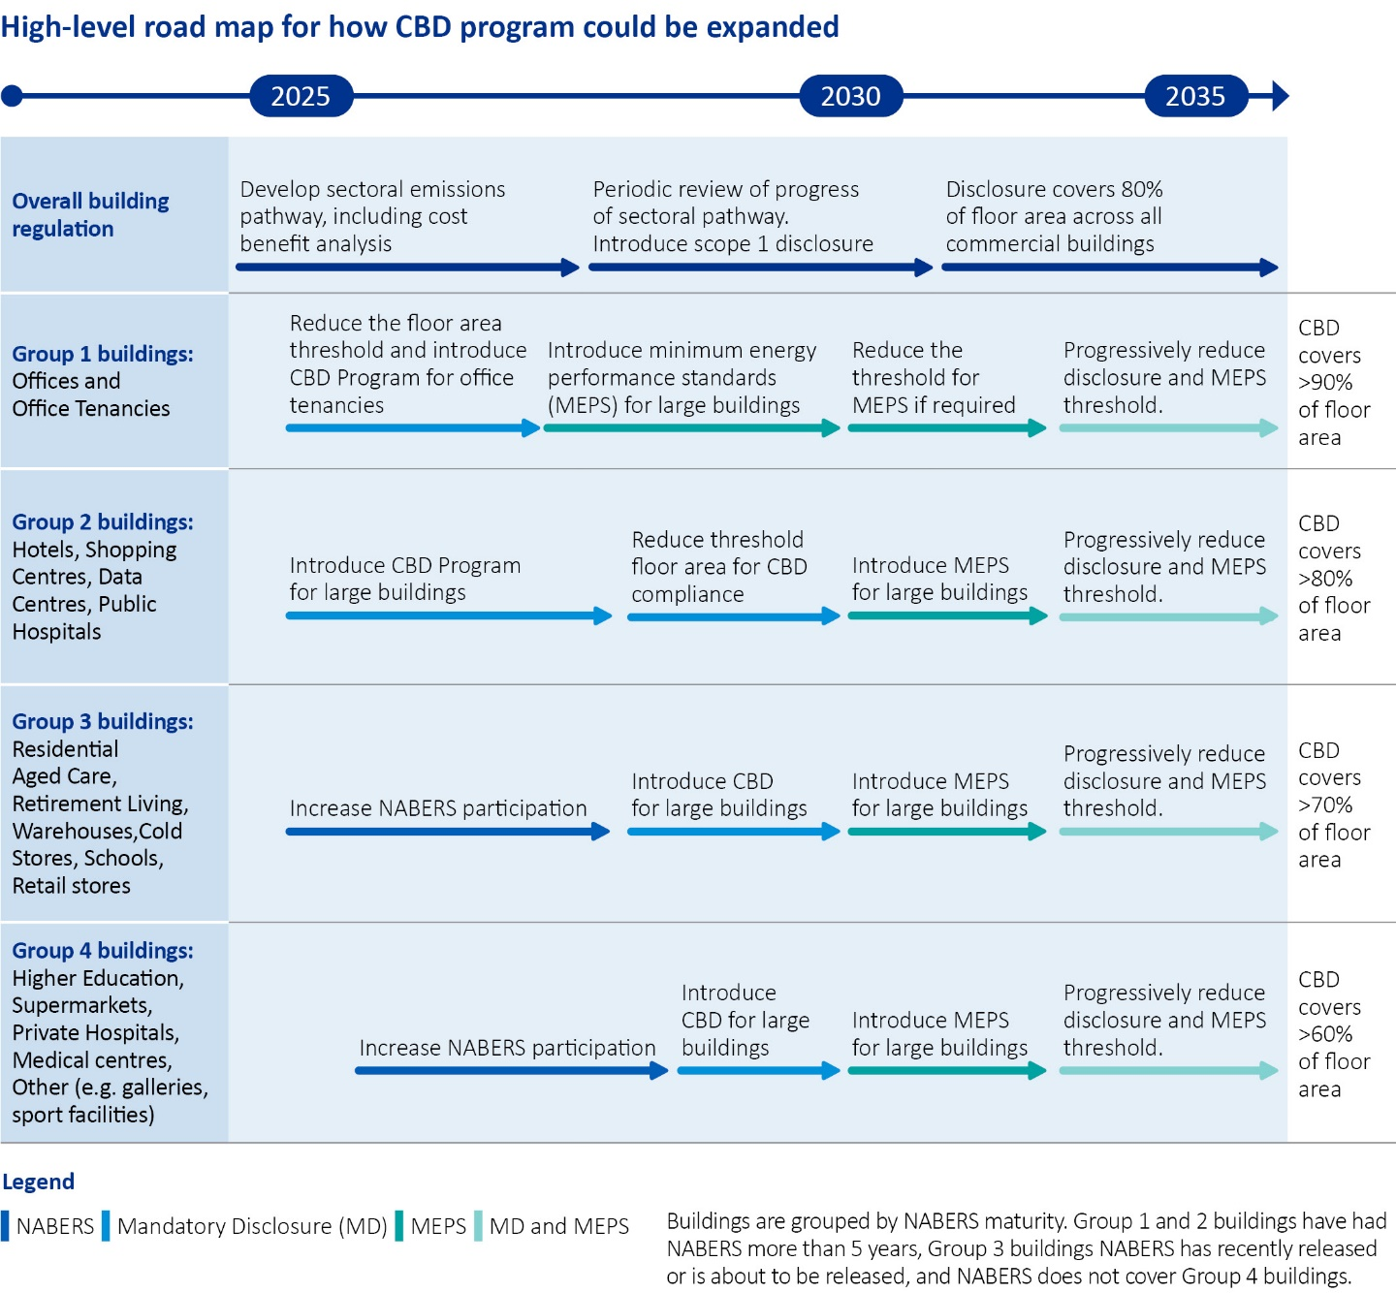

Figure 1 : High-level road map for how the CBD Program could be expanded.

The following principles underpin the above road map for change:

* prioritising early expansion in scope to larger building types where NABERS ratings tools are available.
* pursuing coverage of all significant commercial buildings sectors over time, eventually covering a large proportion of their emissions and energy use with effective regulation.
* phasing in minimum energy performance standards (MEPS) to building types that have first been subject to disclosure requirements.
* specific details on timing, size thresholds, trigger points and disclosure/consideration requirements following more detailed cost benefit analysis, regulatory impact statement (RIS) and industry consultations.

The department is seeking feedback on the above road map, noting that implementing CBD expansion would require further analysis of the costs and benefits particular to the specific sector under consideration.

Specifically, the department is examining options to:

1. **Expand the CBD Program to different types of commercial buildings in line with the suggested road map**. This would mean the CBD Program would be expanded first to more office buildings and to hotels and office tenancies. Other building types that could be included at a later stage include shopping centres, data centres, warehouses, cold stores, residential aged care and retirement living. Expanding to different types of commercial buildings could require different triggers for disclosure than on sale or lease, and different locations for disclosure than in advertising.
2. **Expand the CBD Program to different ownership** structures such as trusts, partnerships and individuals. Currently, the Program is limited in scope to constitutional corporations.
3. **Investigate what energy and emissions information should be disclosed**. Currently, BEECs include the building's NABERS energy rating and a tenancy lighting assessment (TLA) of the relevant area of the building. The department is interested in the usefulness and necessity of a TLA in other building types, and the benefits of requiring disclosure of any other energy or emissions information. Examples include scope one emissions (from on-site activities such as gas use, diesel use or refrigerants) and renewable energy use.
4. **Investigate the future use of minimum energy performance standards** to improve the energy efficiency of any commercial buildings that do not respond to disclosure. Minimum energy performance standards (MEPS) could require specific buildings to meet base level requirements, such as a particular star rating, by a specified date in the future.

These options require amendments to the legislative framework underpinning the CBD Program, including the BEED Act.

### Consultation

The department has gathered a considerable amount of information from stakeholders about the CBD Program through the 2019 review and, more recently, through the National Energy Performance Strategy consultations. This consultation does not seek to duplicate this work. The department is seeking feedback on the road map approach as contained in the KPMG feasibility report, and specific impacts of expanding the CBD Program on particular building types covered by the suggested road map.

To have your say, please go to consult.dcceew.gov.au and complete the survey. An opportunity to attach a written submission will be available at the end of the survey.

Submissions will close at 5pm AEST Friday 13 September 2024.

#### Who do we hope to hear from?

* Owners and tenants of commercial buildings.
* Members of the energy efficiency industry such as energy assessors.
* Investors and others who might use energy efficiency information about buildings.
* Anyone interested in using or publishing the energy rating of buildings, for example hotel booking sites.
* Anyone with an interest in the CBD Program.

**Consultation questions**

1. What are your views on expanding the CBD Program to different types of commercial buildings in line with the suggested road map?
2. Where should disclosure information (e.g. energy ratings) be displayed? Some examples include on advertising (including online advertising), on your business website, in the foyer.
3. What should trigger disclosure? Some examples include on sale or lease, or a periodic trigger such as yearly or once every two years.
4. Who would be most interested in your energy use?
5. What are the barriers to you getting and disclosing your building’s energy rating? What might be needed to help you overcome those barriers?
6. Should other information also be disclosed in addition to the NABERS energy rating? Possibilities include Scope 1 emissions from on-site activities (for example gas use, diesel use and refrigerants) or the NABERS Renewable Energy Indicator which displays the proportion of the building’s energy that comes from on-site renewable energy generated and off-site renewable energy procured.
7. What are your views on the use of minimum energy performance standards to improve the energy efficiency of commercial buildings?

### More information

Learn more about the Commercial Building Disclosure Program at [www.cbd.gov.au](http://www.cbd.gov.au) or email [commercial.buildings.team@dcceew.gov.au](mailto:commercial.buildings.team@dcceew.gov.au).

Read the CBD Program expansion feasibility study at: consult.dcceew.gov.au.

Read about the legal framework underpinning the current CBD Program, including the BEED Act here: [www.cbd.gov.au/program/overview/legal-framework](http://www.cbd.gov.au/program/overview/legal-framework)

Further stakeholder engagement opportunities will be communicated through consult.dcceew.gov.au.

**Acknowledgement of Country**

We acknowledge the Traditional Custodians of Australia and their continuing connection to land and sea, waters, environment and community. We pay our respects to the Traditional Custodians of the lands we live and work on, their culture, and their Elders past and present.

© Commonwealth of Australia 2024

Unless otherwise noted, copyright (and any other intellectual property rights) in this publication is owned by the Commonwealth of Australia (referred to as the Commonwealth).

All material in this publication is licensed under a [Creative Commons Attribution 4.0 International Licence](https://creativecommons.org/licenses/by/4.0/legalcode) except content supplied by third parties, logos and the Commonwealth Coat of Arms.

The Australian Government acting through the Department of Climate Change, Energy, the Environment and Water has exercised due care and skill in preparing and compiling the information and data in this publication. Notwithstanding, the Department of Climate Change, Energy, the Environment and Water, its employees and advisers disclaim all liability, including liability for negligence and for any loss, damage, injury, expense or cost incurred by any person as a result of accessing, using or relying on any of the information or data in this publication to the maximum extent permitted by law.

**Appendix 1: Text for high level roadmap for how CBD program could be expanded between 2025 and 2035.**

|  |  |  |  |  |
| --- | --- | --- | --- | --- |
| Category | Phase 1 | Phase 2 | Phase 3 | Phase 4 |
| Overall Building regulation | Develop sectoral emissions pathway, including cost benefit analysis | Periodic review of sectoral pathway | Disclosure covers 80% of all floor area across all commercial buildings |  |
| Group 1 buildings: Offices | Reduce the floor area threshold | Introduce minimum energy performance standards (MEPS) for large buildings | Reduce the threshold for MEPS if required | Progressively reduce disclosure and MEPS threshold  CBD covers more than 90% of floor area |
| Group 2 buildings: Hotels, Shopping Centres, Data Centres, Public Hospitals | Introduce mandatory disclosure for large buildings | Reduce threshold floor area for CBD compliance | Introduce MEPS for large buildings | Progressively reduce disclosure and MEPS threshold  CBD covers more than 80% of floor area |
| Group 3 buildings: Residential Aged Care, Retirement Living, Warehouses, Cold Stores, Schools, Retail stores | Increase NABERS participation | Introduce CBD for large buildings | Introduce MEPS for large buildings | Progressively reduce disclosure and MEPS threshold  CBD covers more than 70% of floor area |
| Group 4 buildings: Higher Education, Supermarkets, Private Hospitals, Medical centres, Other (e.g. galleries, sport facilities) | Increase NABERS participation | Introduce CBD for large buildings | Introduce MEPS for large buildings | Progressively reduce disclosure and MEPS threshold  CBD covers more than 60% of floor area |